Experiment 4

Strategize Impedance Matching with a Short-Circuited Stub through Measurement of Location and Length of the Stub
Test Case 1
Optimize impedance matching using single stub matching by finding the location and length of the stub for load impedance ZR varied from 100∠30° Ω to 350∠30° Ω, keeping the characteristic impedance Zo = 60 Ω constant (f = 100 MHz).
Code -
clear; clc;
Zo=60; f=100*10^6;
ZR=[100 150 200 250 300 350];
lo=300/(f*10^-6); // wavelength
for i=1:6
Ls=(lo/(2*%pi))*atan(sqrt(ZR(i)/Zo));
Lt=(lo/(2*%pi))*(%pi+atan(sqrt(ZR(i)*Zo)/(ZR(i)-Zo)));
printf('ZR=%d Ls=%f cm Lt=%f cm\n',ZR(i),Ls*100,Lt*100);
end
Output:
Zo = 60 Ω, f = 100 MHz, λ = 3 m → Variable: ZR
ZR (Ω) | Point of attachment Ls (cm) - Sim | Stub length Lt (cm) - Sim | Ls (cm) - Theory | Lt (cm) - Theory
100 | 43.53 | 202.24 | 43.53 | 202.24
150 | 48.07 | 188.76 | 48.07 | 188.76
200 | 51.07 | 181.70 | 51.07 | 181.70
250 | 53.25 | 177.34 | 53.25 | 177.34
300 | 54.92 | 174.34 | 54.92 | 174.34
350 | 56.26 | 172.13 | 56.26 | 172.13
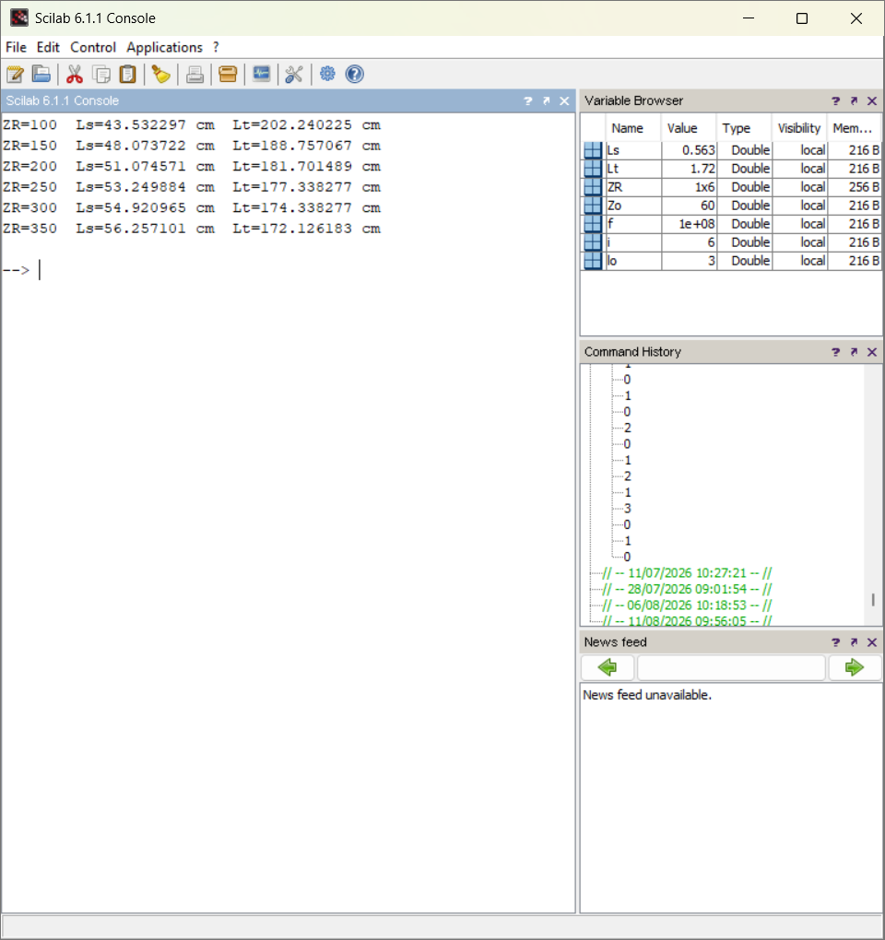
Result:
Impedance matching using single stub matching was optimized by computing the stub location and length for varying load impedance ZR, keeping Zo = 60 Ω constant. Both the point of attachment and the stub length increase with ZR, though the rate of increase reduces at higher ZR.

Test Case 2
Optimize impedance matching using single stub matching by finding the location and length of the stub for characteristic impedance Zo ranging from 600 Ω to 1800 Ω, keeping the load impedance ZR = 100∠30° Ω constant (f = 100 MHz).
Code -
clear; clc;
ZR=100; f=100*10^6;
Zo=[600 900 1200 1500 1800];
lo=300/(f*10^-6);
for i=1:5
Ls=(lo/(2*%pi))*atan(sqrt(ZR/Zo(i)));
Lt=(lo/(2*%pi))*(%pi+atan(sqrt(ZR*Zo(i))/(ZR-Zo(i))));
printf('Zo=%d Ls=%f cm Lt=%f cm\n',Zo(i),Ls*100,Lt*100);
end
Output:
ZR = 100 Ω, f = 100 MHz, λ = 3 m → Variable: Zo
Zo (Ω) | Point of attachment Ls (cm) - Sim | Stub length Lt (cm) - Sim | Ls (cm) - Theory | Lt (cm) - Theory
600 | 18.51 | 128.25 | 18.51 | 128.25
900 | 15.36 | 132.87 | 15.36 | 132.87
1200 | 13.42 | 135.43 | 13.42 | 135.43
1500 | 12.06 | 137.11 | 12.06 | 137.11
1800 | 11.05 | 138.32 | 11.05 | 138.32
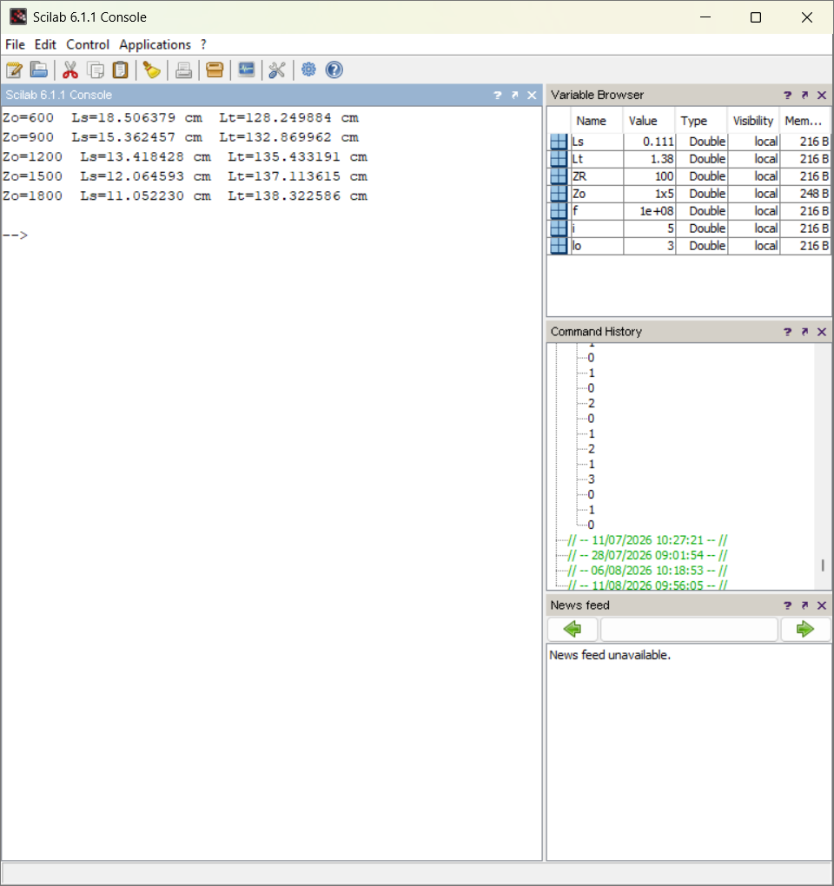
Result:
Impedance matching using single stub matching was optimized by computing the stub location and length for varying characteristic impedance Zo, keeping ZR = 100 Ω constant. As Zo increases, the required stub location moves closer to the load while the stub length increases.

